
Absconding Policy

Date: September 2026
Review Date: September 2027
Lead SLT: Wayne Beech

Approved By: Headteacher Date: 02/08/2026

Introduction

For the purpose of this policy statement, the term ‘absconding’ is used to cover incidents of pupils leaving school, or school activities within the community, unaccompanied and without the prior knowledge of staff.

Pupils at Sallygate School may be very vulnerable in terms of lack of understanding of their own safety, and the significance of school rules relating to attending and absconding. As a direct result of this, the school places high importance on awareness for staff regarding matters of safety, security and support for pupils. We work with pupils to raise their understanding of safe behaviours both in school, in residences and in the community; and provide each pupil with purposeful educational and community experiences which are engaging, creative and suitable to their individual need, interest and ability. Where a pupil or young person is known to present a high risk of absconding and placing themselves or others in danger the school must create an individual assessment of risk reflecting those needs and how to address these in a positive way.
In the event of a pupil absconding from the school or an out of school activity the Headteacher, or a member of the senior leadership and nominated member of staff team becomes the lead person.

Staff Awareness

It is the responsibility of all staff to ensure that they follow security and safety procedures to maintain the safest possible environment for the young person. They must familiarise themselves with the School Behaviour Policy and the individual strategies for support within each pupil’s Classroom Snapshot.
School Register – the school takes registers twice daily.
All staff are required to be vigilant in their monitoring of all pupils’ in attendance.

Risk Assessments

The safety and welfare of the young people is paramount. In order to ensure the continued safety of all children / young people at Sallygate School, individual, environmental and activity risk assessments are carried out and maintained as per needs identified.

Staff Guidance for Child /Young Person Absconding
In the unlikely event that a pupil absconds, either intentionally or unwittingly, staff must activate the following procedure:

- Alert the Headteacher and / or a member of the school leadership team or reception and check CCTV of the last known whereabouts of the pupil. The front gate will also be closed and kept closed until the student has been located.

- The teacher / team leader organises a search of buildings and known places the pupil may go including school grounds. In school, one staff member remains in view of the school or last known location if in the community, while other staff members conduct a further search of the grounds and their allocated zone of the school grounds and surrounded areas. All staff members to ensure they have fully charged mobile phones / radio.

- Ensure that the rest of the pupils are safe and appropriately supervised.

- If a pupil is not located within a reasonable timeframe (10 minutes) or as stated in individual risk assessments, the lead person must contact police using 999 and advise that a pupil is missing, providing a full description, including the clothes they were wearing when last seen.

- The Headteacher / member of the school leadership team to inform the pupil’s social worker, foster carers / house manager and Local Authority to inform them of the situation after 10 minutes or as stated in individual risk assessment.

- Lead member of staff / member of the school leadership team to co-ordinate information and keep all interested parties updated.

- Once a pupil has been found the lead member of staff / member of the school leadership team will brief the police, local authority and foster carers / house manager as necessary.

- A full and detailed report and timeline of the incident must be completed; this must include times, date, significant decisions made, actions taken, when and by whom i.e. police contact, foster carers / house manger informed etc. Please include a police reference number.

Where a pupil attempts to leave the school premises without authority or support, the following procedures should be followed:
- Staff member should stay with the pupil and try to persuade them to return to class.
- Headteacher and/or member of the school leadership team should be informed as soon as possible. The front gate will also be closed and kept closed to prevent the pupil from leaving the school grounds.

Where a pupil is seen to have left the school premises:
- Staff member should follow the pupil and try to persuade them to return to school
- If a pupil is deemed to be of high risk to themselves or others then staff should either adhere to the Physical Intervention Policy, or follow the pupil’s Individual Risk assessment and any other psychological, clinical report etc.
- At all times staff must be aware that active pursuit may encourage the young person to leave the school / grounds / vicinity or panic thus placing them in further danger e.g. risk of running into a busy road. An Incident log on CPOMS must be completed and in accordance with school policy.
- If a pupil has left the immediate vicinity of the school the Headteacher / member of the school leadership team / school reception must be contacted, whereupon the lead person will direct the course of action required.

- Staff should follow the pupil at a safe distance keeping them in sight where possible.

- The lead person may direct additional staff to join the search in a vehicle, taking a mobile phone with them to ensure contact with the school or manager.

- The lead person will contact Headteacher, member of the school leadership team, foster carers / house manager and where applicable other agencies.

- If a pupil has left the immediate vicinity and is no longer in sight then the lead person will make the decision on the next actions to be taken. They will refer to step 4
- If a pupil is not located within a reasonable time frame as indicated in the Individual Risk Assessment, the lead person must contact the police using 999 and advise that a pupil is missing, the time they went missing, age, diagnosis, and any other significant information.

- If the pupil returns of their own volition the lead member of staff will inform Headteacher, member of the school leadership team, foster carers / house manager and where any other agencies already contacted.

- A full and detailed report of the incident must be completed; this should include date, times, significant decisions made, actions taken, when and by whom i.e. police contact, parents informed external agencies etc.

- A full and detailed report of the incident must be completed; this must include times, date, significant decisions made, actions taken, when and by whom i.e. police contact, foster carers / house manger informed etc. Please include a police reference number.
Planned External Activities

- Prior to leaving the premises, the responsible person in charge of the pupil will carry out a Risk Assessment. This form will identify any risk or issues relating to the activity the pupil will be participating in.
- All staff must ensure they are fully familiar with any Risk Assessments and contents of the Classroom Snapshot before carrying out the activity.
- Work Mobile phones should be used for all car/ mini bus/ external activities to ensure staff can contact the school, manager or on call person where necessary.
- Please note if a pupil leaves the building unattended or absconds in the community and there is not an additional staff member available staff should phone 999 and then the on-call contact number while searching the area.

Policy Review Statement
This policy will be reviewed annually or sooner if operationally required.
Plan of search zones - premises
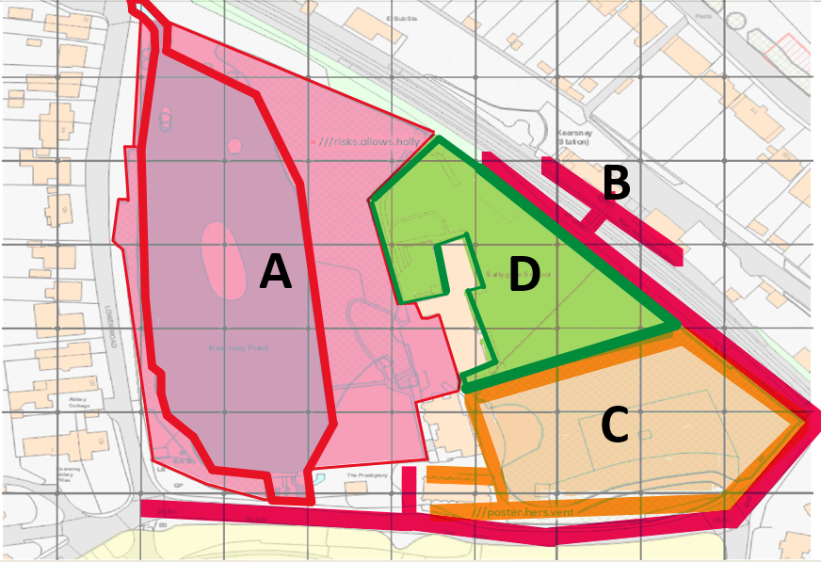

A – Lake and Forest school area.
B – Main road to Kearsney train station and then to Kearsney Abbey.
C – Carpark and forest area up to the train station fencing.
D – Rear of the school building /forest area up to green fencing and fitness equipment area.

