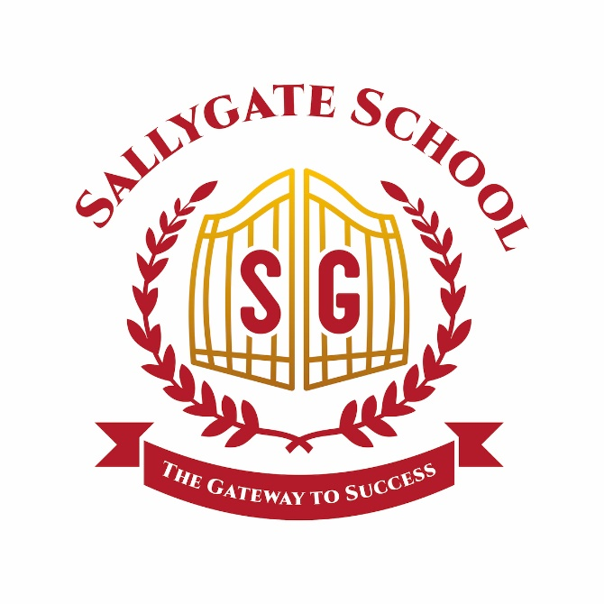

Sallygate School Dress Code Delight

(Uniform Policy)

Date: January 2024
Review Date: January 2027

Lead SLT: Alistair Hammond

Sallygate School Dress Code Delight

At Sallygate School, we're all about creating a friendly and comfy space for everyone. Our uniform is a big part of that, so let's dive into the details with a sprinkle of friendliness!

Chic Choices:

Top-notch Top: Slip into our sleek black sweater featuring the Sallygate logo (black sweatshirt/jumper is acceptable).

Shirt or Polo Bliss: Take your pick between a crisp white shirt or a laid-back polo.

Bottoms Brilliance: Black trousers, shorts, or a skirt—it's your canvas!

Footwear Fun: Strut in style with black shoes or sporty black trainers.

Accessorise with Care:

Jewellery Jive: Keep it classy with minimal jewellery. Think studs for earrings and, if you're rocking a nose stud, it must be a nose stud. Any other jewellery? Kindly cover or remove it before entering the school.

Nails-Should be a safe length, no ridiculous extensions that may cause injury or discomfort.

Active Adventures:

For those action-packed moments, we have a special PE kit. Find all the juicy details on our website.

Senior Pupil Elegance (Year 11):

Recognising the transition to the final year of schooling, our Year 11 senior pupils enjoy a unique dress code. Embracing a smart casual aesthetic, the focus is on a more collegiate vibe while ensuring alignment with health and safety standards. This special dress code reflects the maturity and responsibility expected of our senior pupils as they prepare for the next exciting chapter in their educational journey. It also serves as a subtle nod to the evolving independence and self-expression characteristic of their senior status, creating a distinguished and empowering atmosphere in their final year at Sallygate School.

Dress Code Diplomacy:

Our teachers are the fashion whisperers, making sure everyone is on point.

If someone's outfit is a bit off, they get a friendly reminder (Strike One).

Strike Two and Three:

Strikes Two and Three are more formal.

If things do not align, we chat with parents and carers to help us get it right.

Appeal Avenue:

We get it; life can be a bit tangled. If you are feeling puzzled, chat with the Headteacher within five school days.

Why it Matters:

It is not about rules; it's about creating a place where everyone feels fantastic. The uniform helps us focus on the important stuff—learning and growing together! We all Matter and We all Care.

Thanks for being fantastic and keeping Sallygate School a haven of warmth and understanding. You are all stars in our book! 🌟

PROCESS

1. Identification of Non-Adherence:

- Teachers monitor students for compliance with the uniform policy during school hours and activities.

2. First Instance (Strike One):

- A friendly verbal reminder is given to the student about the uniform policy.

- The teacher documents the first instance of non-compliance.

3. Second Instance (Strike Two):

- A written warning is issued to the parents or carers, detailing the uniform violation.

- The teacher documents the second instance of non-compliance.

4. Third Instance (Strike Three):

- A final written warning is issued to parents or carers, emphasising the importance of adhering to the uniform policy.

- Parents or carers are required to bring the correct uniform to the school within three school days.

5. Resolution Meeting with Parents/Carers:

- If the correct uniform is not provided within the specified time, a meeting with parents or carers is initiated to discuss a resolution.

6. Temporary Collection of Student:

- In cases of prolonged non-compliance, if the correct uniform is not provided, the student may be temporarily collected from school until compliance is achieved.

7. Appeals Process:

- Parents or carers have the right to appeal uniform-related decisions.

- Appeals should be submitted in writing to the Headteacher within five school days of receiving a warning.

This process is designed to be supportive and focuses on collaboration with parents to ensure that students align with the school's uniform policy in a positive and understanding manner.

In the outlined process, senior leadership would typically step in if the issue persists despite the initial interventions by class teachers. Here's a breakdown of when senior leadership might become involved:

1. Repeated Instances (After Strikes Two and Three):

- If a student continues to violate the uniform policy after the second and third instances (Strikes Two and Three), senior leadership may become involved.

2. Resolution Meeting:

- When the resolution meeting with parents or carers takes place, senior leadership may be present or take over the communication to emphasize the importance of uniform adherence.

3. Escalation of Consequences:

- If the situation remains unresolved even after the resolution meeting, senior leadership may consider additional steps or consequences.

4. Appeals Process:

- Senior leadership may play a role in reviewing and responding to appeals submitted by parents or carers.

Senior leadership is likely to step in when there is a need for a higher level of intervention, especially if the non-compliance persists despite the efforts of class teachers. Their involvement ensures consistency in addressing uniform issues and provides a higher level of authority in resolving the situation.

