POLICY STANDARD

Sallygate School
Positive Relationship and Behaviour Management Policy

POSITIVE RELATIONSHIP (BEHAVIOUR) POLICY

Version 1:01

Date Released: 27th September 2017

INTRODUCTION

All pupils at Sallygate School have struggled to maintain a mainstream school placement for a variety of reasons; consequently, a vital part of the school’s role is to support the varying degrees of challenging SEMH, behaviour and social communication needs they often exhibit. Alongside this they also often suffer from disruptive patterns of attachment and early years trauma.

We believe ‘Restorative Approaches’ is a fundamental component in helping the school community achieve this aim. Restorative Approaches offer a framework that enables young people to develop their social and communication skills

Rationale

This document provides a framework for the creation of a happy, secure and orderly environment in which students can learn and develop as caring and responsible people. It is written for all members of the Sallygate School to allow each one to understand the policy of the school and to apply it consistently and fairly.

- To ensure appropriate behaviour and language throughout the school
- To encourage and praise greater effort in both work and behaviour
- To ensure a whole School approach to behavior management is used and approved by all the staff, teaching and non-teaching.
- To ensure that carers are informed and are aware of the school disciplinary procedures and behavior management approach.
- To provide a system of rewards to encourage good behaviour and to try and reverse continuous and habitual negative behaviours.
- To ensure a safe, caring and happy School
- To consistently reinforce Fundamental British Values (FBV)
- To promote good citizenship
- To promote self discipline
- To prevent bullying

Our Policy:

- Aims to articulate the central values, rights and responsibilities which underpin the management and development of student behaviour within our school.
- Is based on the principles of Restorative Approaches. The Restorative approach will provide an alternative to the belief that punishment will change behaviour and achieve compliance. It also enables support for emotional and social development to be differentiated according to individuals’ needs.
- Is written in the belief that an understanding, shared throughout the school and community, of principles, procedures and practices, is the most effective method of achieving a united school community of which all its members can be proud.
- Incorporates the requirements of the Prevent Duty into this and other policies.
- Reflects the SMSC agenda and promotes British Values.

PHILOSOPHY

1. We believe that good behaviour is an integral part of the learning process. Individual students have the right to work and develop in an atmosphere of respect, trust, security, honesty and openness: where positive relationships are valued within the school and the wider community.

2. The key elements in this philosophy are:
- Clear, shared learning goals;
- Creation of a safe and caring environment;
- Enabling, recognising and celebrating individual achievement;
- Tolerance and understanding of others.

3. Positive relationships (between students, their peers and adults) are integral to the effective implementation of this policy.

4. In order to promote the success of this policy, the school will endeavour to ensure an effective partnership between adults at home and at school.

5. The Policy will be applicable in school, on school trips, and also where appropriate when students are representative of the school in their journey to and from school.

6. The Policy will rely on the Principles of Restorative Justice, which :

- Focus on harm caused by the wrong-doer and actively seek ways of repairing that harm.
- Help create dialogue and communication.
- Are fair, open, and honest; treating all participants with respect.
- Allow all participants to engage, learn and gain a shared understanding, within a safe environment.
- Encourage accepting responsibility, reparation, reintegration, restoration, and behavioural (and cultural) change.
- Provide opportunities for participants to openly state their views, listen to others and acknowledge their views.

RIGHTS AND RESPONSIBILITIES

All members of the community of Sallygate School share the rights to:

- Work safely and productively;
- Share information, skills learned and concepts grasped – without distraction or disruption;
- Have recognition and reward for successes and efforts;
- Have self-esteem enhanced;
- Work in a co-operative manner and treat each other with respect and dignity;
- Welcome visitors and similarly to respect their rights;
- Have equal opportunity to succeed irrespective of race, gender, religion, sexuality, ability or disability (see separate policies).
- The School council represents the views of all pupils

During establishment phases, tutors will involve their groups in the creation of a set of commonly agreed Rights and Responsibilities (a.k.a. Classroom Norms) and, in turn, will ensure these are clearly displayed in class. To aid staff in this process, an example of Classroom Norms can be found in the appendices to this Policy (Appendix 1).

TEACHING AND LEARNING

The development of students’ social, emotional and behavioural skills will be encouraged by establishing high expectations in all lessons, together with tutor time and PSHE.

Through regular meetings, both informal and formal, pupils who are identified with more challenging behaviour are provided with additional support and/or changes to curriculum or provision with the focus ultimately on reintegrating the pupil as soon as possible back into the learning environment. Through the restorative process, the school aims to support these young people, helping them to understand their behaviour, the effect it has on their learning and that of others.

The way in which all members of the school community teach and learn from each other when behaviour and attendance is unacceptable, is also influential. As pupils grow through the school there should be regular explicit opportunities for learning about how to act in keeping with the school’s values and beliefs. In these practical strategies for intervention, full use should be made of support from the wider community of the LA, Attendance and Inclusion Service, Police, , YOS, Social Services multi-agency teams, etc.

ROLES AND RESPONSIBILITIES

The promotion of positive behaviour is the responsibility of the school community as a whole.

The Management Committee, Head Teacher and Staff are responsible for ensuring that all aspects of the school’s Positive Relationship Policy and its application promote equality for all students.
The roles include:

a) The Management Committee supporting and promoting the principles underlying the school’s Positive Relationship and Behaviour Policy.

b) The Head Teacher and Senior Leadership Team in framing and establishing an environment that encourage positive behaviour and regular attendance.

c) The Head Teacher provides support and facilitates training for all staff around behaviour management and restorative practice; additionally, the HT co-ordinates the formal conferencing process and the teams of conference facilitators and peer mediators.

d) All staff in ensuring that the policy is consistently and fairly applied and that students are taught how to behave well.

e) Students who are able to behave in a way that promotes the learning of all in the community.

f) Carers and Parents in taking responsibility for their child’s behaviour inside and outside the school to maintain high standards of behaviour.

THE USE OF RESTORATIVE APPROACHES AT SALLYGATE SCHOOL

The approach will require all staff working with our students to be aware of the principles and language of Restorative Justice, and the ability to apply them to resolving situations in their classes, corridors, and elsewhere in the community. The principles and use of Restorative Approaches will be a regular feature in the school’s Continuing Professional Development programme, both at the beginning of the school year and where appropriate at other times.

In addition to this, a team of trained staff will be identified to use the model to resolve more difficult problems in a formal and structured manner. These staff will been trained to apply Restorative Approaches to conferences with the “Wrong-doer and the Harmed”, with the aim of creating restoration and reparation between those involved.

The Restorative Questions:

- What happened?
- What were you feeling / thinking at the time?
- What do you think / feel about it now?
- Who has been affected by what has happened?
- In what way?
- What impact has this incident had on you and on others?
- What has been the hardest thing for you?
- What do you think needs to happen to make things right?
- What do we need to do make sure this doesn’t happen again?

The questions are neutral and non-judgemental, they are about the wrong-doer’s behaviour and its effect upon others, and they are open questions which require an answer. They take everyone from the past (what happened) to the future (repairing harm) and require people to reflect on who has been affected. They are likely to help the wrongdoer develop some empathy for those affected.

How to use the Restorative Questions:

The Restorative Approach model can be applied in a number of ways, ranging from informal work in corridors and classes to formal conferences with the wrong-doer and the harmed including working with whole classes (see Appendix 2). Examples of restorative approaches in action include:

Restorative Chat – informal chat using restorative questions, this does not include formal referral, preparation, contract or debrief but should/may include a follow-up; individual member of staff takes initiative and leads process.

Corridor/Impromptu Conference – informal conference that does not include formal preparation, but may include an informal contract and a follow up; individual member of staff takes initiative and leads process.

Circle or Classroom Conference – a more-structured conference that requires a degree of pre-conference preparation and, possibly, a contract, debrief and a follow-up session. Referral for support can be made to the BT for the students concerned.

Formal RJ Conference – Requires formal pre-conference preparation, possibly a home visit, formal referral, a contract and a formal setting, a de-brief after the conference and a follow-up session. This process must be led by a trained conference facilitator.

N.B. Restorative Justice Interventions should be recorded as appropriate on the school’s behaviour tracking system.

Unsuccessful conferences or refusal to take part:

Unless all have agreed to take part in a Restorative Intervention, it will not proceed; all have to be willing participants. If during an intervention any of those taking part are unable or unwilling to proceed, the intervention will close and an alternative resolution will be implemented.

If those involved fail to comply with expectations of the agreement, alternative solutions including the school’s sanctions (see below) may be negotiated or applied to the wrong-doer.
See Appendices 2, 3 and 4 for further information.

REWARDS AND SANCTIONS

In general, the School believes that rewards are much more effective than punishment in encouraging and motivating students and should be used as a proactive incentive for success. Likewise, wherever possible Restorative Interventions should initially be used in preference to sanctions to manage inappropriate behaviour; where this is not possible or where it has failed, an appropriate sanction may be negotiated or applied.
The Reward System at Sallygate School is designed to target learning and attitude, at whole-school level, includes A-stars, ‘catch-me-cards’ and the weekly merit points system with a reward for those achieving a Gold award, a range of end-of-term and a whole-school end-of-year award. Similarly, the behaviour tracking system can be used to record ‘positive incidents’ and can lead to letters/postcards being sent home to notify parents and carers. See Whole School Reward Policy for further detail.

SANCTIONS

Consistent with the school’s ethos of supporting pupils rather than blaming and punishing, excessive and/or ‘knee-jerk’ reliance on sanctions is to be avoided; instead, sanctions - escalating in nature - need to be used proportionately, flexibly and creatively to respond to each individual and the specific situation and only after suitable reflection, discussion and negotiation as necessary has taken place. For example, a child who has caused damage to the building might better take part in a restorative meeting with the Class Teacher and/or literally repair the damage by removing graffiti or similar. Furthermore, where a more traditional sanction - such as a detention (see below) - is unavoidable, staff should take every opportunity to ensure this becomes part of a restorative process through guided discussion/exploration of negative actions and their impacts on others in the school community (or beyond), the development of contracts (with or without any other participants in the conflict), or simply the use of circles to build skills and promote strategies for positive behaviour.

At times negative behaviours may be of a degree such that despite all attempts to use the restorative approach it may be necessary for the young person to receive a more traditional sanction. The choice of sanction should be determined by the extent and impact of the inappropriate behaviour.

It is a requirement that staff record all serious incidents of unacceptable behaviour using the school’s behaviour tracking system; individual incident reports also include a record of what members of staff have done to address the poor behaviour so that students are able to modify and improve it.

Exclusions

For some misdemeanours it may be appropriate for a pupil to be excluded from the rest of the class for a period of time. This may take the form of an “internal” or External, fixed-term exclusion. Internal exclusions can take place immediately and allow the pupil to have some reflection time while they work in an alternate space with 1:1 supervision. Work is provided for the pupil. Internal exclusions may be appropriate for persistent, low-level disruption or refusal to work in lessons or in instances where there has been an altercation with another pupil, to allow for a period of “cooling off.”

Where there is compelling evidence that a pupil has intended causing harm to another person or object, a fixed-term exclusion may be issued by the HT. Work will be sent home, along with a copy of the standard, LA-approved letter explaining the reason for the exclusion plus the process for reintegration.

Reintegration

In line with the general use of Restorative Approaches at Sallygate School, pupils returning from fixed-term exclusion will be expected to participate in a Restorative Reintegration Meeting with their carer/parent and appropriate members of staff.

USE OF REASONABLE FORCE

In routine circumstances staff should refrain from using force; however, it is important that staff are fully aware of the legislation and guidance provided by the DCSF/DfE with regard to the circumstances when reasonable force could be used by a member of staff, what is acceptable, and what a member of staff should consider before they intervene in a particular situation. As part and parcel of this, staff need to be aware of and act in accordance with any Positive Handling Plans (risk assessments) for individual pupils.

It is important that staff should ensure that they have exhausted all other options and are confident they could justify and explain their use of force before making a physical intervention. In short, it is the final option and should be avoided unless there is no other reasonable alternative open.

Detailed guidance regarding the Use of Reasonable Force is to be found in the school’s Physical Intervention Policy. All staff are Team Teach trained as soon as possible after appointment.

All physical interventions that constitute some form of restraint should be recorded in the Bound and Numbered book before the end of the school day. The Bound book is monitored by the HT and a member of the management committee and is discussed at the teacher meetings.

SUPPORT SYSTEMS FOR STUDENTS

Above and beyond the high levels of support and adapted curriculum available to all at Sallygate School, a number of students will need additional support to manage their behaviour and attendance. The school will support these students and proactively work to pre-empt escalating behaviours, truancy and attendance problems, and other signs of disaffection. Students causing concern are identified by individual members of staff and the appropriate response will be arranged through Vulnerable Pupil meetings.

SUPPORT SYSTEMS FOR STAFF

All staff have a responsibility to deal with incidents of misbehaviour when it occurs, respond accordingly and where appropriate - possibly in conjunction with a ‘fielding’ colleague - record the incident and the follow-up action on the school’s behaviour tracking system.

Incidents of a more serious nature should be referred upward through the network indicated (Roles and Responsibilities) for resolution elsewhere in the school community.

Staff who have repeated difficulties with a particular individual or teaching group should seek initial support and guidance from their Line-Manager or, alternatively, Behaviour Manager or the HT.

If misbehaviour is so serious that teaching and learning cannot continue, staff should use the mechanisms in place (send LM or pupil) to summon additional support. It is important that staff follow up the exiting of a student from their lesson and attempt to ensure the situation is not repeated in their next lesson through means consistent with the School’s restorative approach (including appropriate use of thought-out sanctions). Likewise, staff need to be familiar with the School’s protocols and scripts for a ‘managed return to class so that the risk of an unsuccessful return is minimised after the initial incident has been dealt with elsewhere by colleagues (see Appendix 4).

INVOLVEMENT OF CARERS AND PARENTS

The involvement of carers/parents is, of course, a key ingredient to successful outcomes for pupils: to promote this class tutors are expected to make use of standard home-school contact arrangements including regular daily phone calls (or emails) to exchange information, build relationships, and routinely communicate both positive news and achievements as well as behavioural and academic issues as and when necessary.

Carers/parents of pupils causing particular concern should be contacted at the earliest appropriate stage to discuss strategies and support for the individual student. This will vary from child to child and, as such, no hard and fast rules govern the point at which contact of this type is necessary.

Parents/carers of students at risk of exclusion because of persistent poor behaviour will be actively involved in the development of individual Pastoral Support Programmes (PSPs). The PSP will have specific targets and identify behaviours that need to be reduced and improved. PSPs should be reviewed regularly by the member or members of staff responsible (usually the Leadership Team).

INVOLVEMENT OF OUTSIDE AGENCIES

From time to time, we may enlist support from outside agencies such as the Police service to educate and inform pupils about potentially risky behaviours such as fire-starting, using illegal drugs and carrying and using offensive weapons. This will be carried out in a sensitive manner in line with the school’s PSHE curriculum.
We will also offer services such as Counselling or Drug education/support as required.

CONFISCATION

All staff should consider the following criteria when deciding whether to confiscate an item from a student

- An item poses a threat to others: for example, a laser pen is being used to distract and possibly harm other pupils or staff;
- An item poses a threat to good order for learning: for example, a pupil uses a personal music-player in class during lesson time;
- An item is against school uniform rules: for example, a pupil refuses to take off an outdoor coat on entering a classroom;
- An item poses a health or safety threat: for example, a pupil wearing large ornate rings in PE may present a safety threat to other students;
- An item which is counter to the ethos of the school: for example, material which might cause tension between one community and another;
- An item which is illegal for a child to have: for example, racist or pornographic material. Protocols for how to deal with such items can be agreed with local police. This list includes tobacco, alcohol, illegal drugs etc
- Following advice from the Police we have decided that any child bringing a weapon to school will be sent home and an exclusion will follow.

CONSULTATION

To be fully effective the Positive Relationship (Behaviour) Policy needs support from the whole school community. Any proposed changes to the school’s policy will be discussed by the Leadership Team and the Management Committee and shared with all staff and pupils as appropriate.

MONITORING AND EVALUATION

The School will regularly audit the effectiveness of the Positive Relationship Policy including regular analysis of data provided by the behaviour tracking system. This will inform the School Development Plan and lead to identification of targeted training for staff implementing the policy. The audit will consider effectiveness of support, including the use of exclusion, sanctions and Restorative Justice/Approaches.

APPENDICES:

- Examples of Classroom Norms
- Restorative Approaches ‘pyramid of practice’
- List of staff trained to facilitate conferences
- Scripts for managed return to class following an incident
- Reward system

APPENDIX 1 Classroom norms

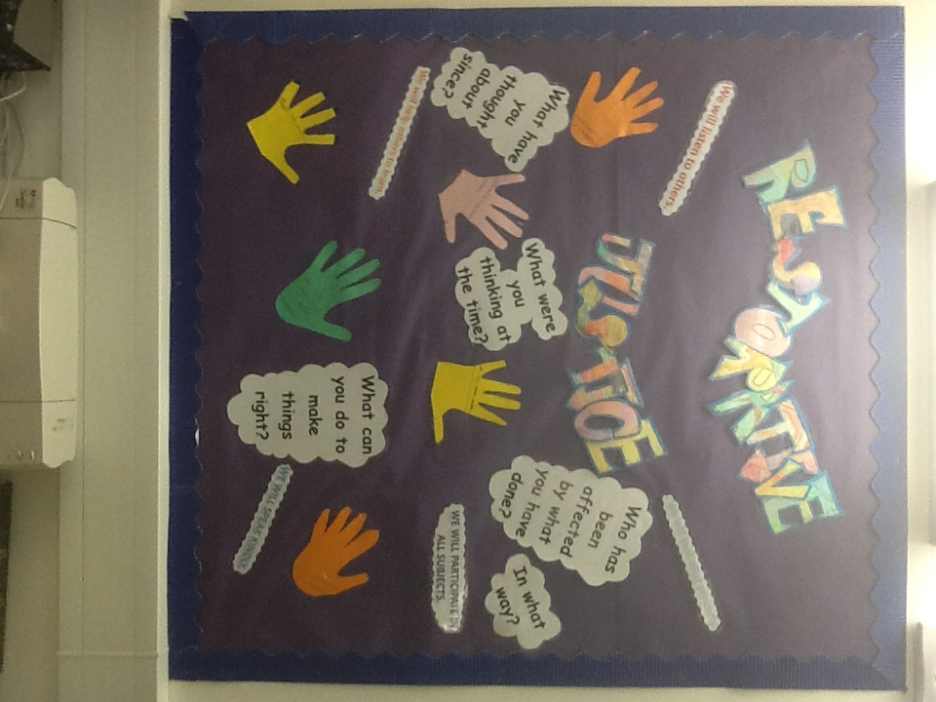
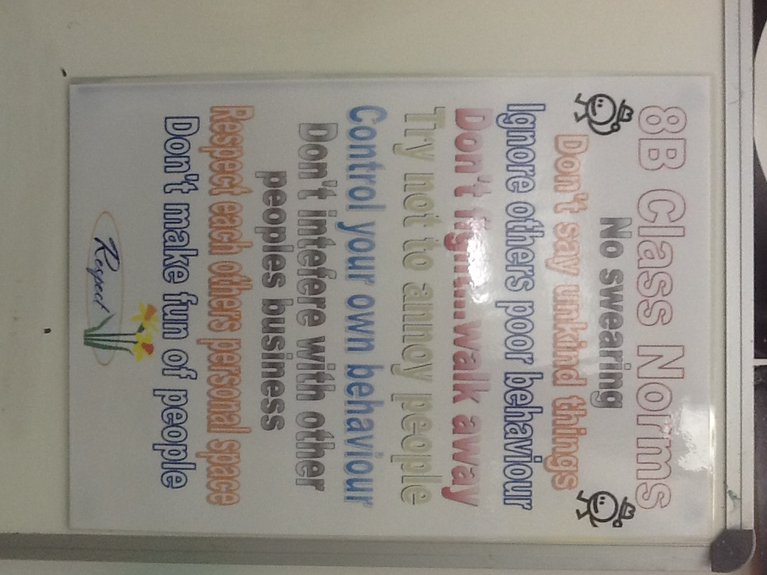

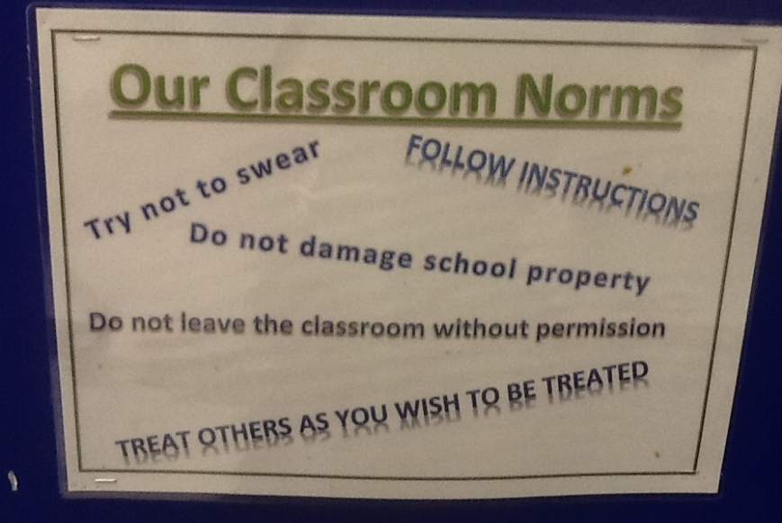

Appendix 2: Pyramid of practice

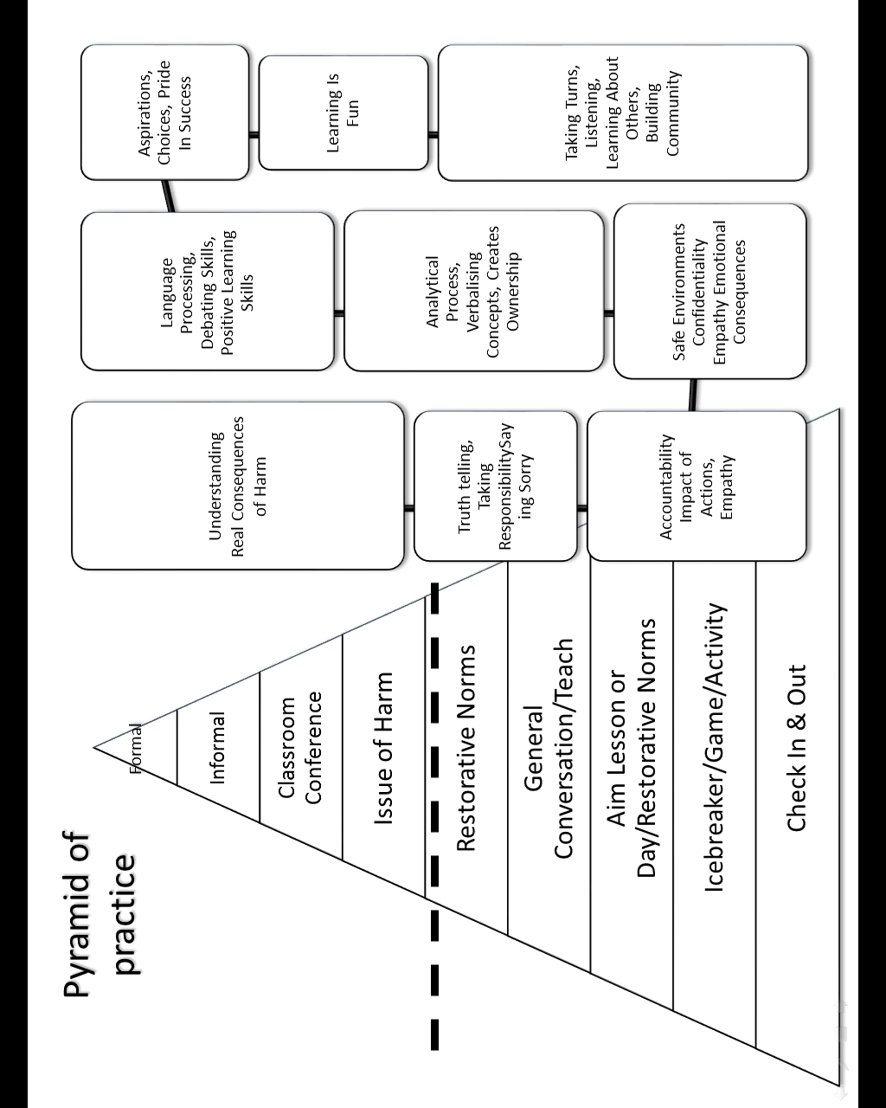

APPENDIX 3: Staff trained to facilitate conferences

As of April 2017

Warren Deane
Michele Smith

APPENDIX 4: Scripts for managed return to class

- On return to class, pupils are given a fresh start.
- Apologies are not demanded.
- Staff use an agreed script to help pupils return successfully.
- E.g. “We have talked about the incident and X would like to come back to work now.”
- This indicates to the teacher that no discussion is needed at this time and the pupil should be allowed to return quietly to work.
- Or “We have talked about it and X would like to talk to you when possible.”
- Or “X and I would like to talk with you later if possible.”
- After an incident, all staff aim to repair and rebuild relationships as soon as possible.

Appendix 5: Sallygate School Reward System.

The reward system has had a positive effect on behaviour and has also been proved to be a valuable tool for behaviour management strategies, for the majority of students that attend Sallygate School.

Staff are involved in the model and implementation of the reward system. Pupils voice their opinions and ideas. Feedback is given to pupils by staff. The reward system allows all pupils to achieve within the learning and social environment of the school. This means that staff can encourage pupils as individuals and as a group to reach their maximum social, educational or behavioural potential.

The reward system that the school provides to its students includes a number of different rewards strategies to meet their individual needs:

The school reward system a has a weekly credit system ;

Each lesson, pupils can be awarded up to 10 points for their combined learning and attitude. At the end of the week, points are totalled and certificates will be sent home by tutors using the schools agreed points system.

The points need to be awarded in a consistent manner (see below) and the suggestion is as follows:

ATTITUDE, LEARNING - REWARD SYSTEM
0 points: For not being in the lesson or for leaving the lesson and failing to return within 10 minutes.

1 point: For being in the lesson and not being disruptive. Some work is completed but little effort made.

2 points: Bronze level, for completing work and having acceptable attitude and effort.

3 points: Silver level, the pupil has made considerable effort to manage their attitude and language and to complete their work.

4 points: Gold level, the pupil has made a real effort with their attitude and language and has participated well in the lesson. The student has been polite and helpful throughout the lesson.
5 points: A* award (gold plus), the pupil has behaved exceptionally well and has made exceptional effort with their work.
This award needs to be given according to the usual standard from the student, so that if the tutor/TA feels they have made a real effort compared with their usual performance, an A* may be awarded.
These awards should be awarded sparingly so that they are highly valued by students and a cause for celebration.

Rewards
The rewards will be decided in discussion with the school council.
Pupils will receive weekly Gold/Silver /Bronze certificates depending on how many points they achieve.
There will be end of term rewards and Bronze/Silver and Gold end of year reward trips linked to overall points and ‘catch me cards’ gained each week.

Totals required to achieve Gold/Silver/Bronze will be decided on a weekly basis with the young person to ensure a personalised approach based on each young person’s level of need and expected behaviour and learning.

Pupil of the Week
Pupil of the Week is nominated by tutors TA’s and the pupil is awarded a personalised reward e.g Lucky Dip. Pupil of the week is a pupil who has stood out for particularly helpful, polite or improved Learning, Attitude.

Reward Time
At the end of each mini term, the pupils with the most overall points and the “most improved” pupils will have the option of a trip out to the bowling alley or similar or a gift voucher if they do not want to go on the trip.

Achievements Day
A trophy will be presented to the pupil with overall most points and also one for the most improved at the end of the school year.

The school reward system is an integral part of the Restorative Justice Approach and is dependent upon enthusiasm and commitment from both staff and pupils.

