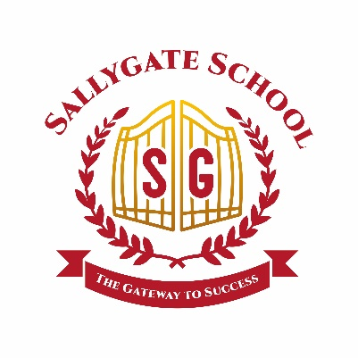
Non-Smoking and Vaping Policy

Date: September 2024
Review Date: September 2025

Approved By: Date:

Aims
The Sallygate School Non-Smoking and Vaping Policy aims to fulfil the obligation as set out in law to "develop and foster a healthy organisation for staff" and "to give non-smokers the right to work in an environment that is free of tobacco smoke, whilst acknowledging the needs of people who do smoke."

Procedures
The Sallygate School acknowledges that people may need to take breaks during the working day, including breaks to smoke or vape, however in accordance with Channels and Choices policy, these should be minimal and in agreement with the relevant line manager.
School staff who are smokers are expected to go, in groups of no more than two, to designated areas only which must be away from the view of pupils or anywhere within view of the School including the car parking areas. Smoking or vaping is not permitted in pool cars or company cars.
Senior staff are responsible for ensuring that relevant staff comply with this policy. Persistent and/or intentional breaches of the policy will lead to disciplinary action under the Disciplinary Procedure.
Any visitor to our premises breaking the conditions of this policy will be asked to stop smoking/vaping or to leave the premises.
Pupils are not allowed to smoke or vape at or anywhere near the school premises and all pupils receive education with regard to smoking as part of their Science and PSHE lessons.

Monitoring and Reviewing
This Policy will be monitored and reviewed as part of the regular cycle of reviews, unless changing circumstances require an earlier review.

