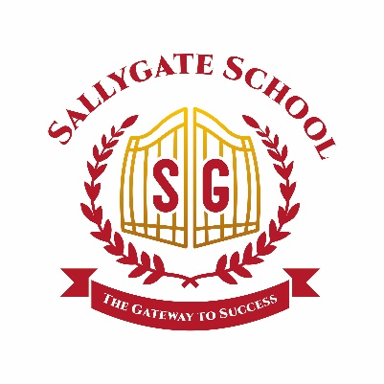
Admissions Policy

Date: September 2024
Review Date: September 2025

Approved By: Date:

Legal Framework

This policy has due regard to all relevant legislation and statutory guidance including, but not limited to, the following:
- Equality Act 2010
- Human Rights Act 1998
- School Standards and Framework Act 1998
- DfE (2021) ‘School Admissions Code’
- The Education (Independent School Standards) Regulations 2014

This policy operates in conjunction with the following school policies:

- Pupil Equality, Equity, Diversity and Inclusion Policy
- Data Protection Policy
- Special Educational Needs and Disabilities (SEND) Policy

Introduction

The Sallygate School provides 39 weeks of full-time education for boys and girls of 8-17 who have Attachment, Trauma, Social, Emotional and Mental Health needs (SEMH).
Pupils attending the school are referred via KCC DPS contract or Channels and Choices as part of a joint service including care and education. Every effort is made to ensure that the child is appropriately placed and that the provision offered by the school matches the needs of the child. The school is permitted to select pupils with reference to general or special ability or aptitude, provided that the way in which the ability or aptitude is assessed is not discriminatory.
Consideration
To summarise, in all cases pupils will be considered for admission if:

- They have a current Education and Health Care Plan, or if EHCP planning is agreed with the Local Authority. In some cases pupils are considered without an EHCP; these pupils will be supported in obtaining a EHCP where/if appropriate.
- Funding for the placement has been formally agreed with the Local Authority.
- The special needs of the pupil are such as can be met in the terms of registration of the school.
- The provision is such as can be met by the school in terms of its registration.
- All up-to-date information concerning the pupil, including the most recent reviews, IEPs and reports etc, will be provided by the funding agency.
- Placing Authorities and their social workers formally accept the school’s policies as presented at application for admission.
- Pupils and carers agree to comply with school rules and the learning and behavioural expectations of the school and placing authorities, home and where applicable, parents agree to support the school in this adherence.
- The child/young person's admission will not significantly disrupt the education or jeopardise the safety of the other children/young people in the school.
- There is a place available in the appropriate class/year group.
- The school will respond to formal consultation within the allotted timeframe, as set out in the DPS contract.
- A two (2) stage formal consultation will commence if the referrals team feel that the child or young person is a match for the school, year group and/or peer group.
- Initial observation stage will commence and 2 members of the SLT will undertake observations in the current setting or home, whichever is applicable.
- Following a referral meeting, if a match is successful, formal notification will be sent to the LA to say we can meet needs.
- Parents will be contacted via the LA once a decision has been made.
- A phased transition will be drawn up once an agreement has been made.
This policy will be reviewed on an annual basis and the next review will be July 2025.

